VySkan
Product Name | 4G Cat1 GPS Tracker
Product Model | VF36
Rugged. Precise. Versatile.
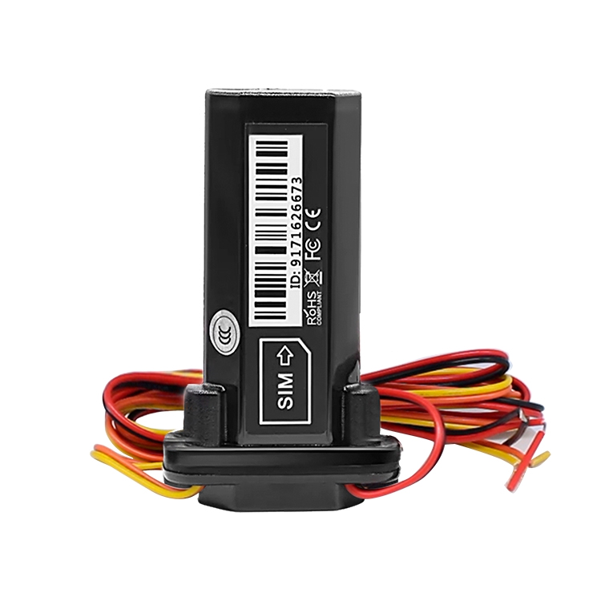
Engineered for harsh environments and diverse fleet applications, the Vyskan VF36 is a robust 4G Cat1 GPS tracker. Combining an IP67 waterproof design with an ultra-wide operating voltage, it delivers reliable real-time visibility and comprehensive remote asset control for everything from motorcycles to enterprise fleets.

- Core Value
- IP67 Rugged Durability
Enclosed in high-quality ABS plastic, the VF36 features an IP67 grade rating, ensuring complete protection against dust and water ingress for reliable outdoor deployment.
- Ultra-Wide Voltage Compatibility
Operating seamlessly on a DC 9V - 90V range, this device is a universal solution for electric new energy fields, passenger vehicles, taxis, rent vehicles, and motorcycles.
- Precise Multi-Mode Positioning
Utilizes a GPS+BDS+LBS location mode to achieve precise positioning with an accuracy of 5 meters.
- Proactive Security & Control
Equipped with comprehensive alert functions including power off alarm, over speed alarm, vibration alarm, movement alarm, and illegal engine on alarm. It also features ACC detection and supports remote fuel/oil cut off (or optional engine stop).
- Target Applications
- Enterprise Fleet Industry & Taxis: For robust tracking and remote fuel control.
- Insurance Industry & Auto Finance: For risk mitigation using illegal engine on and movement alarms.
- Motorcycles & Electric New Energy Fields: Leveraging the IP67 waterproof housing and 9-90V wide voltage range.

- Technical Specifications
  - Cellular & GNSS
Category | Specification | Description
Frequency Bands  (E Version) | LTE-FDD:B1/B3/B5/B7/B8/B20; GSM: B3/B8 | Optimized for European broadband connectivity.
Frequency Bands  (SA Version) | LTE-FDD: B1/B2/B3/B4/B5/B7/B8/B28/B66; GSM: B2/B3/B5/B8 | Optimized for South American and global markets.
SIM Card | Standard SIM card | Readily available form factor.
Module Brand/Chip | ZKMicro AT6558R | High-performance satellite tracking.
Start Time | Cold Start: Average 32S |  Hot Start: Average 1S | Rapid satellite acquisition.
Sensitivity | Tracking: -162 dBm | Maintains strong signal lock.
3.2 Power & Electrical
Category | Specification | Description
Work Voltage | DC 9V - 90V | Ultra-wide range compatible with a vast array of vehicles.
Work Current | 12V/ average 40mA | Standard active tracking mode.
Sleep Current | 12V/ lower than 10mA | Ultra-low power consumption mode.
Internal Battery | 140mAh (3.7V Polymer battery) Optional | Powers the device for backup functions.

3.3 Interfaces & Expandability
Category | Specification | Description
External Port | ACC detection port one way | Accurately monitors vehicle ignition status.
Vehicle Control | Extensible oil off: can be connected to one | Enables remote fuel/oil cut off or optional engine stop.
Antennas | Built-in antenna (PIFA antenna) & Internal GPS antenna | Highly integrated design.

3.4 Physical & Environmental
Category | Specification | Description
Device Dimension | 90.6mm * 57mm * 20mm | Compact footprint.
Weight | 68g | Lightweight design.
IP Grade | IP67 | Waterproof and dustproof.
Work Temp | -20°C - 75°C | Reliable operation in diverse climates.
Work Humidity | 10%-85%RH non-condensing | Resilient in humid environments.
- Built for Rapid Integration
- Standard Protocols: Natively supports TCP transmission and offers a choice between standard JTT808 or GT06 protocols.
- OTA Ready: Supports dual-mode remote upgrades (Platform + SMS) to minimize maintenance costs.
- A personalized service prepared for you
- 1× VF36 Sample Device (Pre-configured)
- Full API & Protocol Documentation
- 1-on-1 Technical Support from our Field Engineers
- Contact us
Website：https://vyskan.com/
Email: marketing@vyskan.com

